**Setting up the environment for Selenium Grid:**

In this example, I am going to show you how to work with selenium Grid using Virtual box. I will be using my laptop as hub, and the instances I create on VM Box as nodes. The following picture shows you what I am doing.

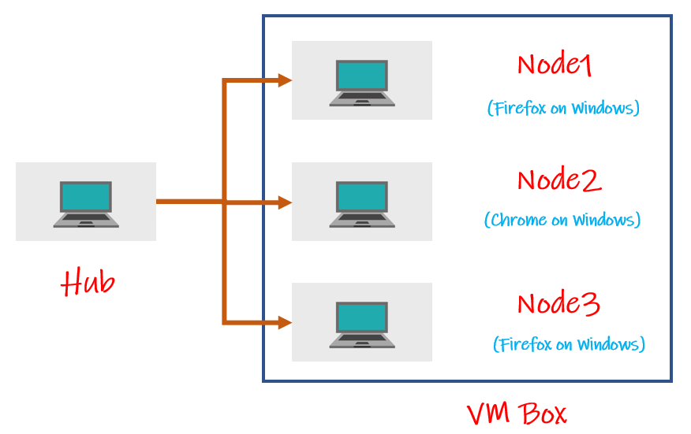

I am going to create a VM Box with three instances. I am going use my laptop as hub and use the three instances as nodes.

**Setting up VMBox and network for Selenium Grid:**

Download VMBox and install windows as one instance on VMBox. Go to google and search VMBox Download or you can download it from the following link.

<https://www.virtualbox.org/wiki/Downloads>

You also need to have ISO files of the platform you want to install on VMBox. Since I want to install windows instance on the virtual machine, download Windows ISO file. (I downloaded windows 10 ISO file).

You also need to have windows key while you are installing the instance on VMBox. You can use your own key for that.

Now open VMBox and click on “New” at the top.

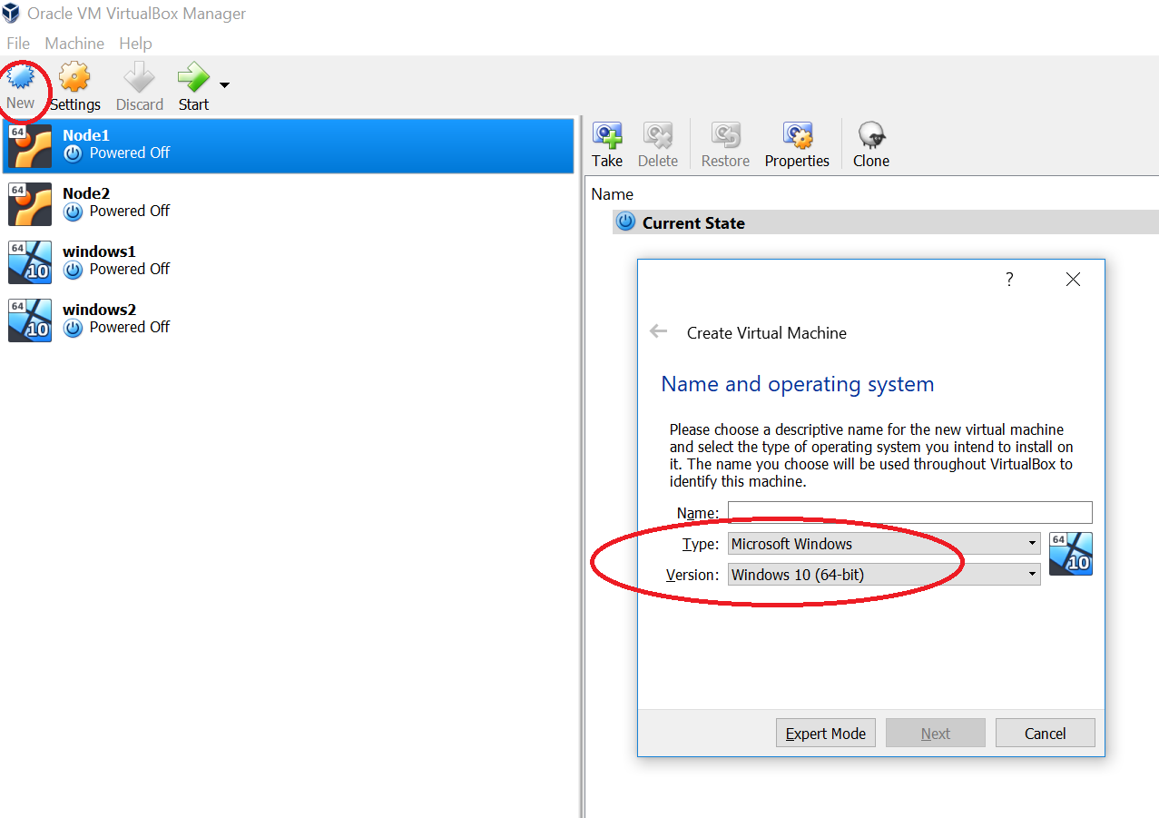

Select the operating system as Windows and select the version of the platform you want to install. Since I downloaded windows 10 ISO file and sicne my system is 64 bit I selected as “Windows 10 (64 bit)”. Give a name to the instance. I gave it as Windows3.

Now allocated RAM memory for this. I have allocated around 3GB.

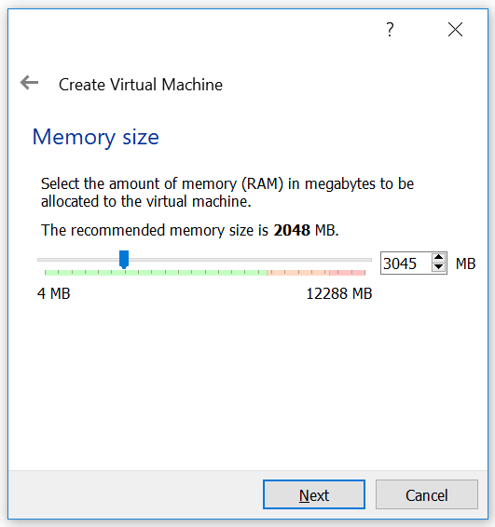

Select “Create Virtual Hard Disk now” and click on “Create”.

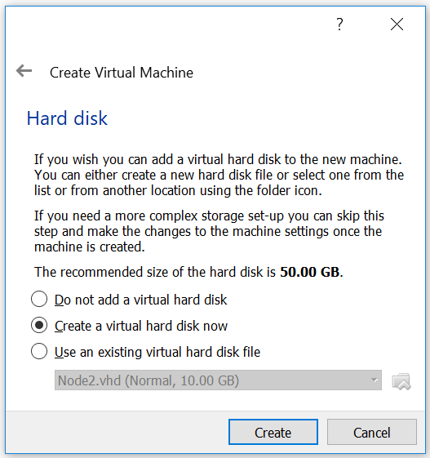

Now select VDI(Virtual Box Disk Image) and click “Next”

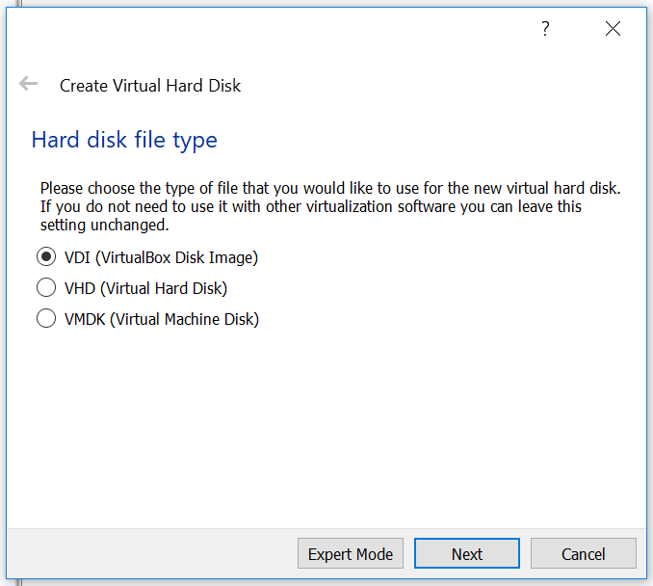

Now leave the default images as they are and click on “Create”.

It will create an instance. Now we have to install windows on it.

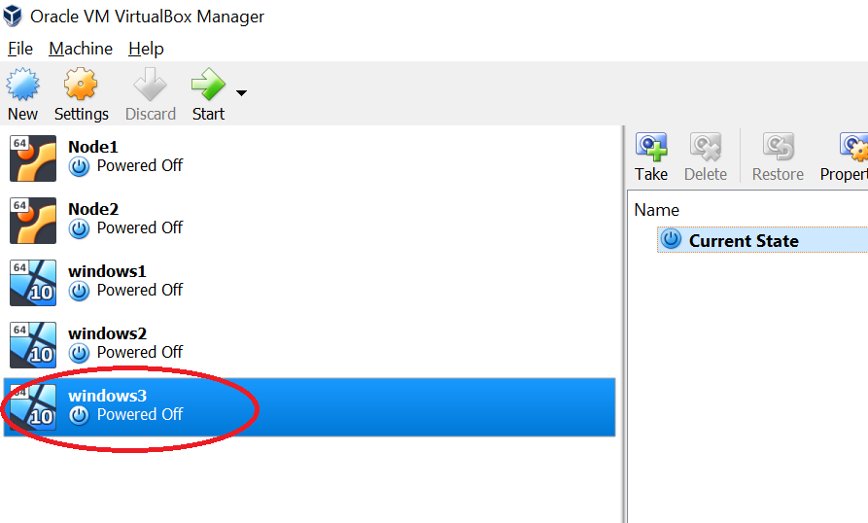

For installing windows on the machine, select the new instance you have created and click on settings and go to storage. Clcik on the CD symbol there and select the ISO file you have.

Now click ok.

Now click on start and it will open the system and go through the steps and install windows on it.

Once everything is completed, you should be able to see the windows machine started.

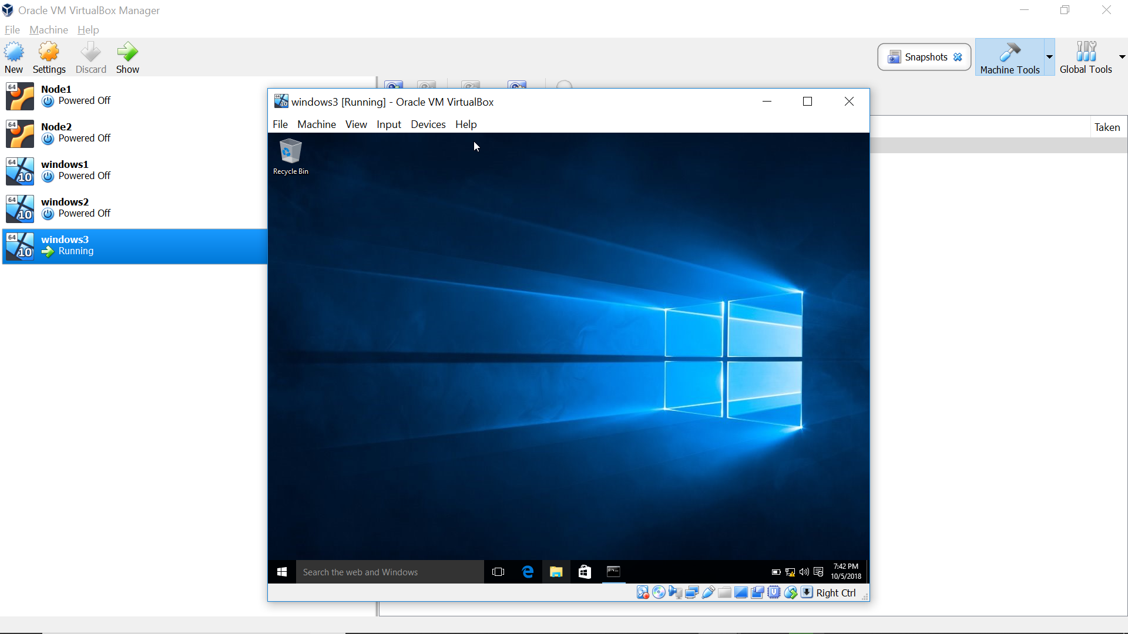

Now go to command prompt and type “ipconfig”. You will see IP address like 10.0.2.15.

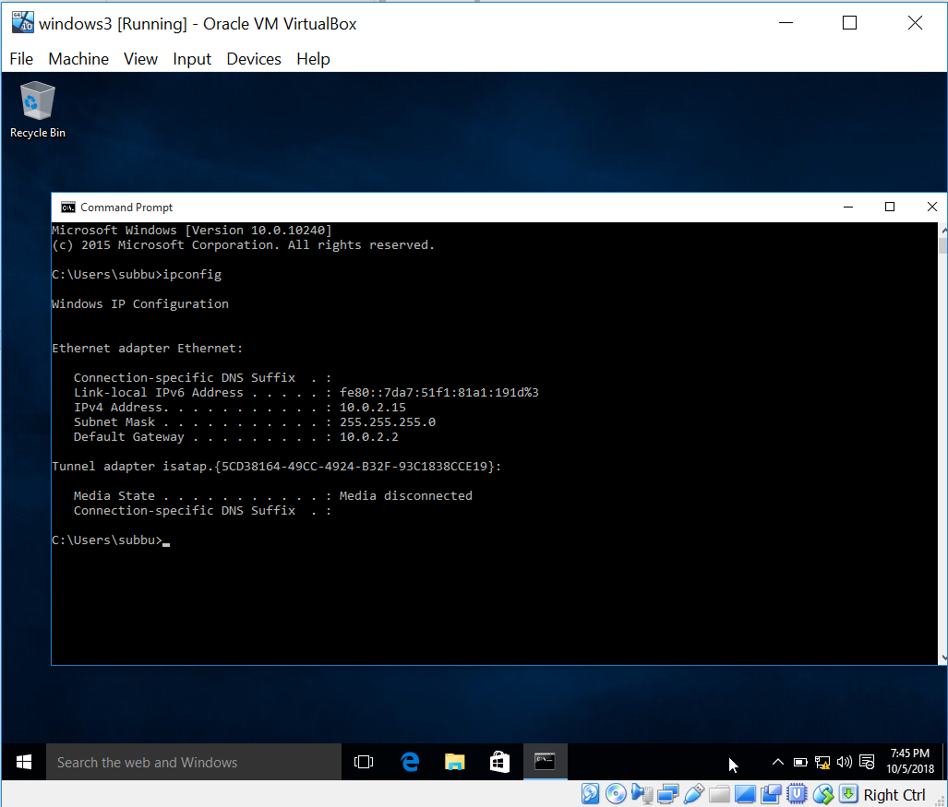

This is the IP address provided by NAT which is the default adapter. This won’t work for connecting from our local machine to the VMBox instance. We need to add another adapter which Host Only adapter.

So, power off the instance and on the VMBox go to settings for the instance and go to Network. Here you will see that the default adapter is “NAT”. Go to “Adapter 2” and enable it and add “Host Only Adapter”.

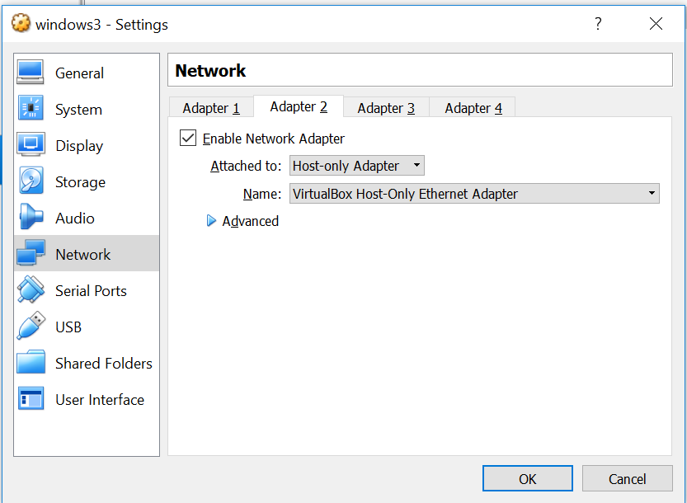

Click ok and start the windows machine you created.

Now if you check the IPAddress in command prompt you will see two IP addresses. One is the NAT address and the other is the Host-Only Adapter address. The Host-Only adapter IP address which looks like 192.168.56.102 will be used for connection between Hub and Node.

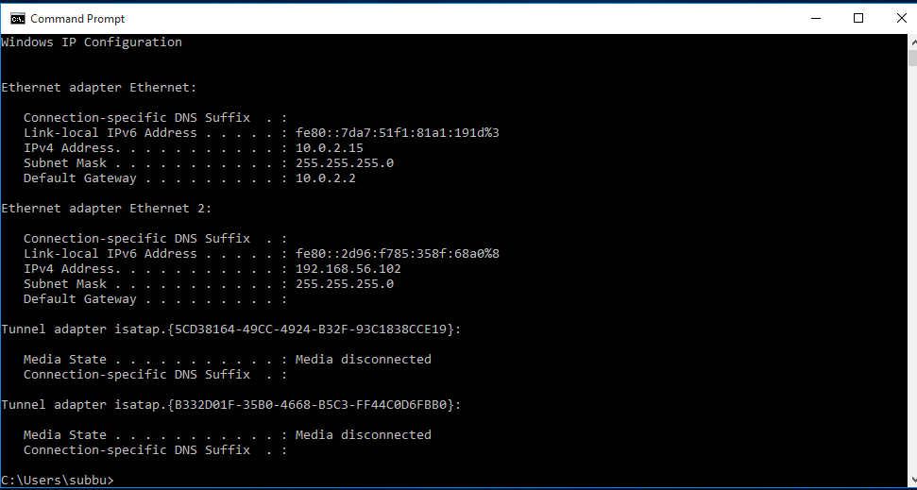

Like this set up a few instances.

On each of the instances

1. Install Jdk on these instances and set the paths
2. download the browsers(firefox) you need and install them
3. download the selenium stand alone server
4. download the driver.exe files for the browsers (Edge: MicrosoftWebDriver.exe, Firefox: geckodriver.exe, Chrome: Chrome.exe)
5. Disable windows firewall (Ping for node to hub and hub to node and see if they are working, if not disable firewall)

Place the driver.exe files and the selenium stand alone server in the same folder.

So, now your system is ready to setup selenium Grid.